Joint Research Ethics Committee (JREC)

MANUAL DOCUMENTATION

**About the JREC**

The JREC is an independent ethics committee established by the Deanery of the University of Zimbabwe-College of Health Sciences (UZ-CHS) and the Parirenyatwa Group of Hospitals.

**The Functions of JREC**

* To ensure that all research conducted by the University of Zimbabwe-College of Health Sciences and the Parirenyatwa Group of Hospitals adheres to the highest scientific and ethical standards.
* Assuring that all protocols submitted to the JREC have a favorable risk-benefit ratio for research participants and that the benefits and burdens of research are distributed equitably.
* Monitoring ongoing research activities at the Parirenyatwa Group of Hospitals and the UZ-CHS, as well as ensuring that ethical standards are upheld throughout the investigations.
* Advising the UZ-CHS and the Parirenyatwa Group of Hospitals on policies and procedures governing the ethical conduct of research.
* Serving as a research ethics resource for the UZ-CHS and the Parirenyatwa Group of Hospitals.

**The features of the JREC**

**JREC Portal Landing page**

This landing page displays the Researcher, JREC Administrator, and JREC Reviewer, to which the user has access by logging in with his or her JREC account.

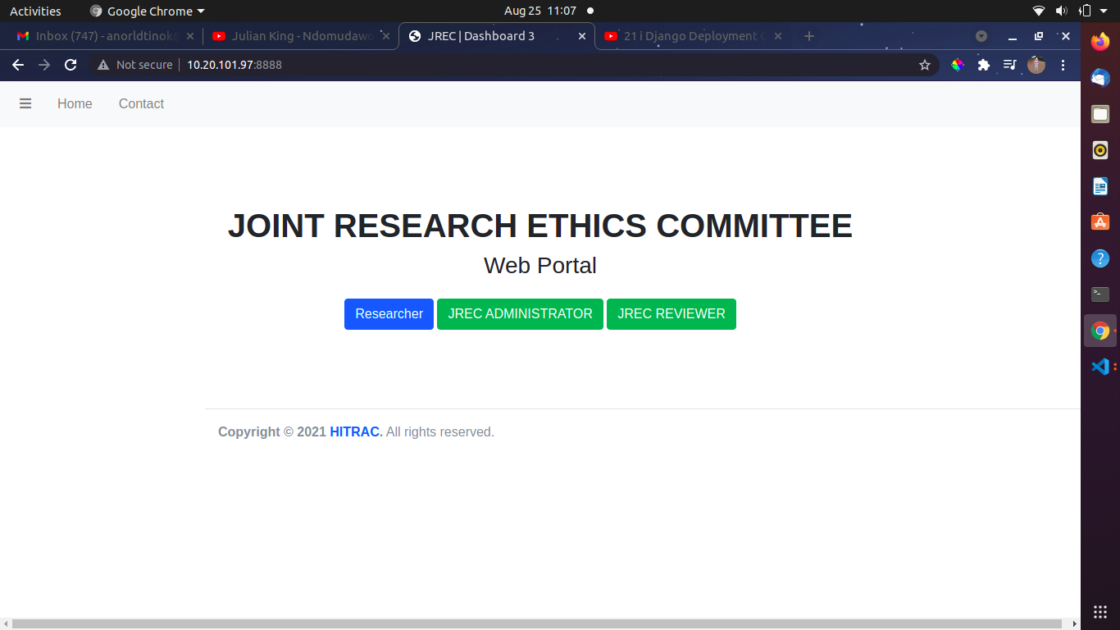

**Researcher Page**

On the far left of the researcher dashboard, there are two major modules: the Apply now module and the Application status. If a user wants to apply, he or she will click the apply now button and be directed to the application form. The diagram below demonstrates this.

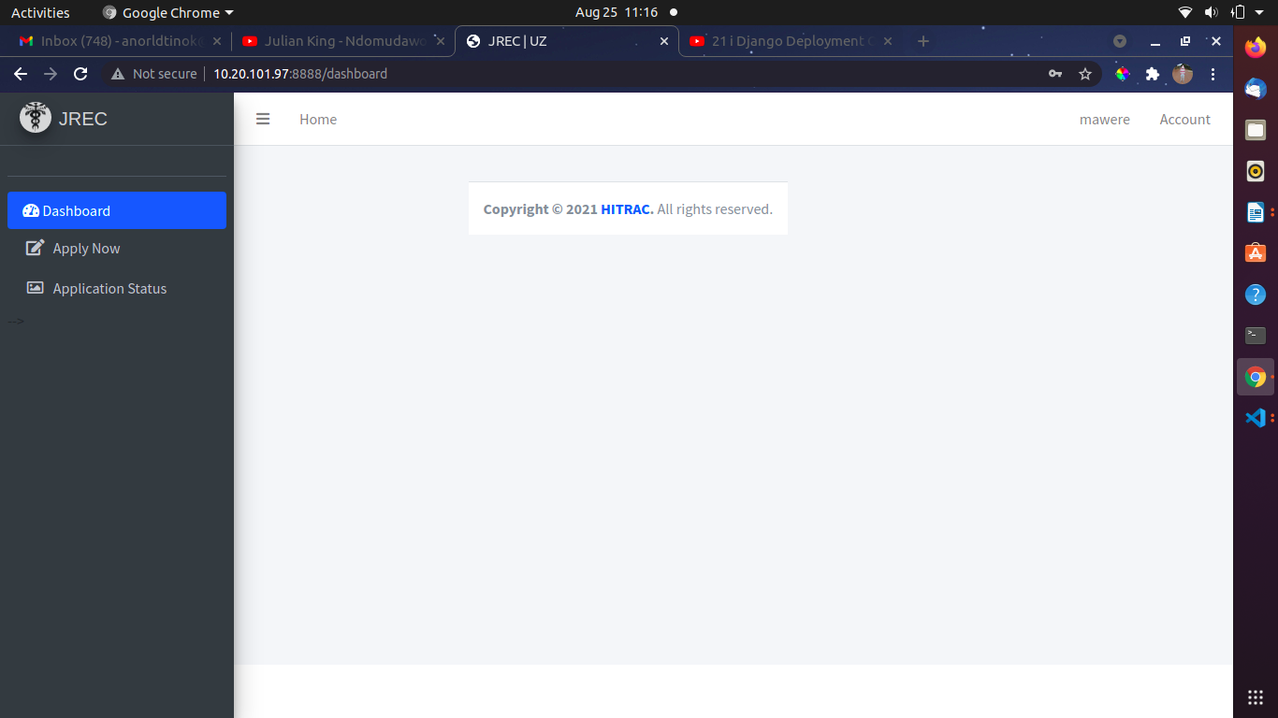

**Application status**

When the researcher selects the application status, it displays the form where he or she will enter his or her information.

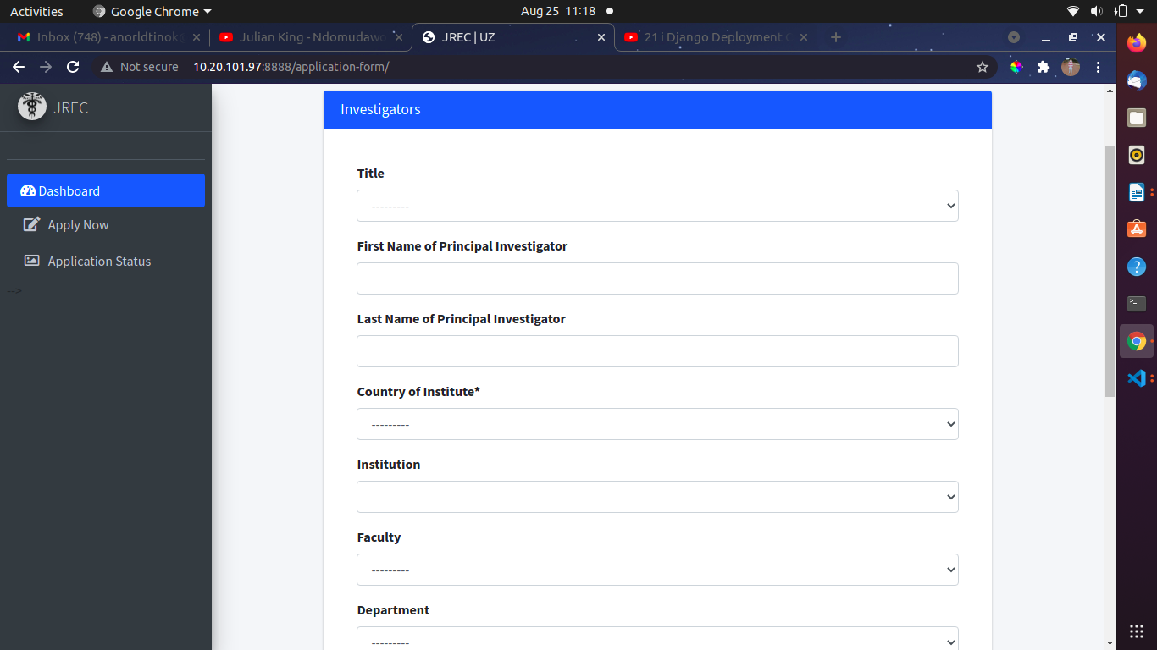

After completing the first section, the system will direct you to the second section, where you can enter the specifics of the proposed research.

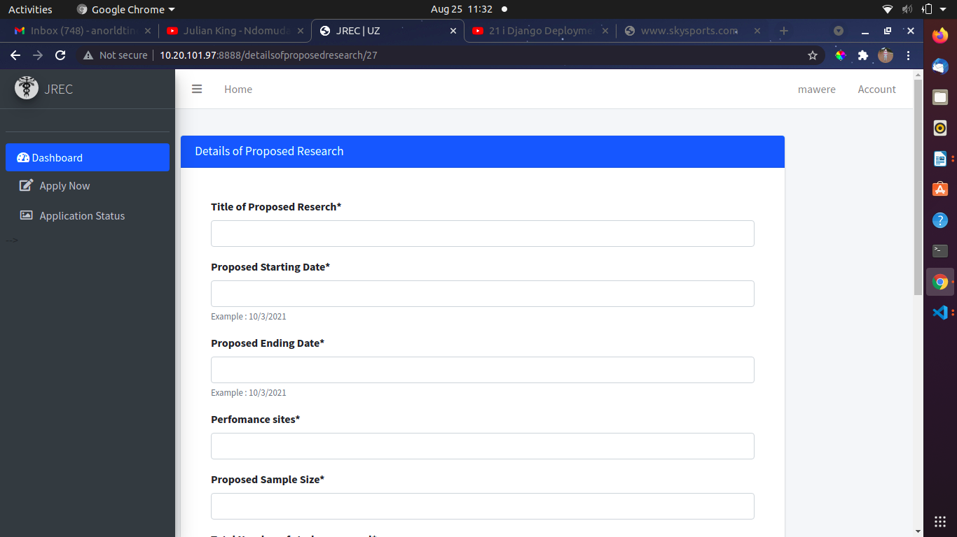

The system will direct you to the third section after you enter the details of the proposed research.

Population: Proposed Inclusion Criteria will be displayed in the third section.

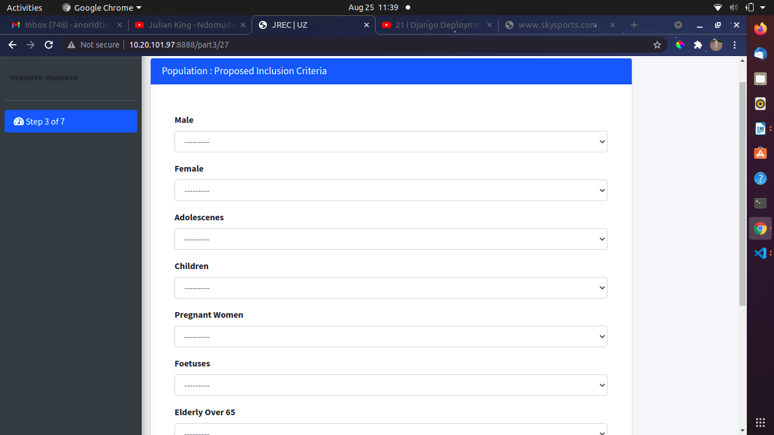

Following completion, the system will direct you to the next form, which displays different types of studies (check all that applies)

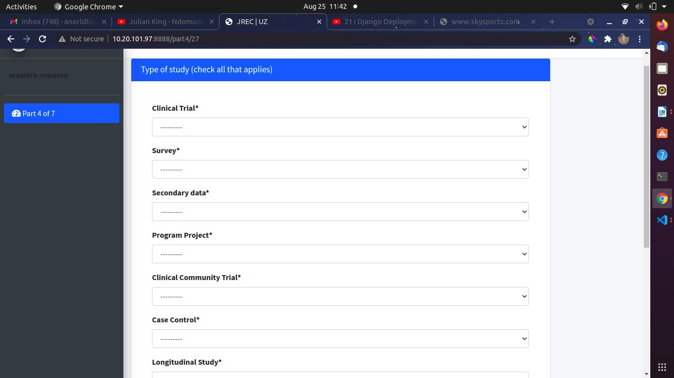

After you complete that form, the system will direct you to another form called Consent Process, where you will be able to fill out all of the details.

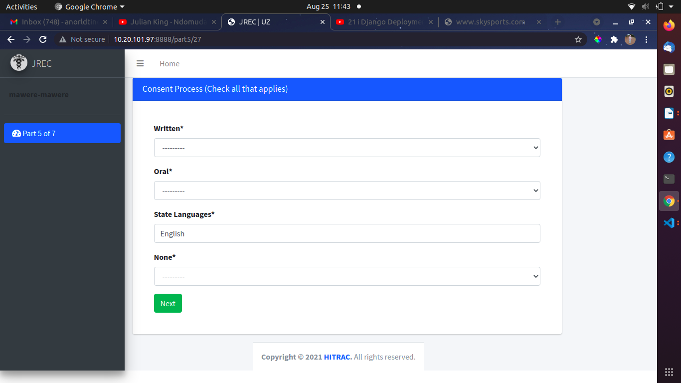

After pressing the next button, the system will take you to the next page, where a researcher will fill out the following information on the image below.

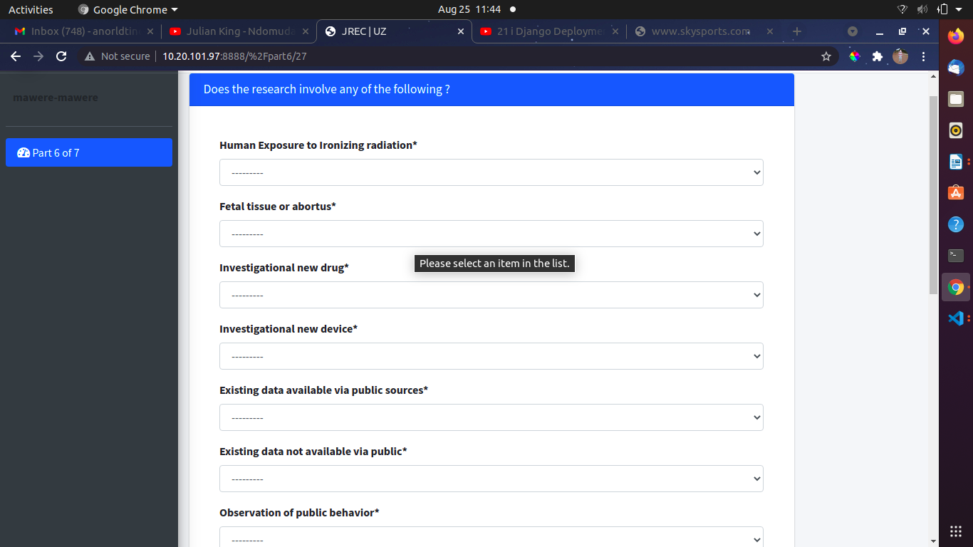

This page displays the executive summary, which provides a researcher with some guidelines before uploading all of the required documents.

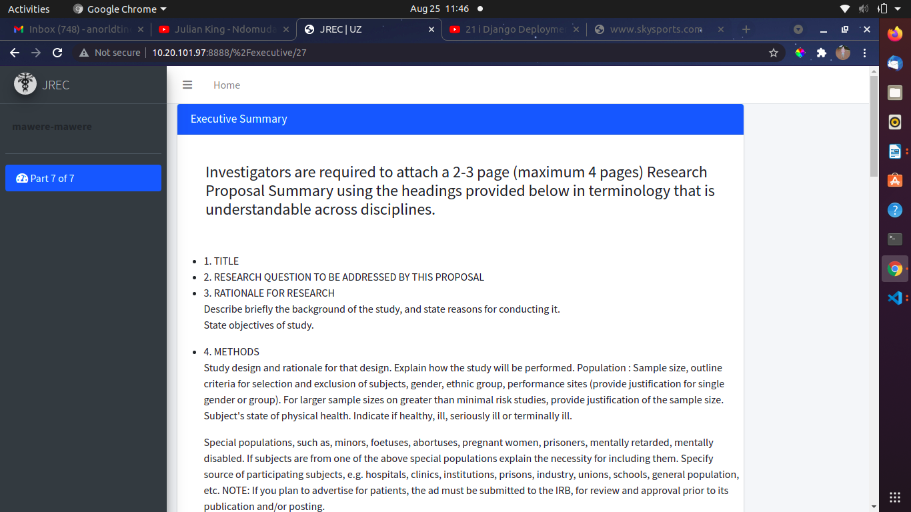

This page allows the user to attach and submit his or her Research Proposal.

The image below demonstrates this.

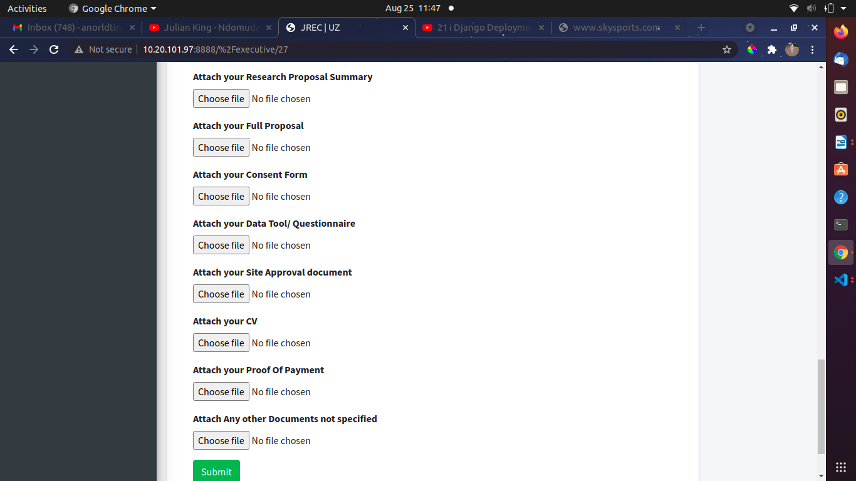

After submitting the Research Proposal, the system will redirect you to the next page, where the user will sign and submit the assurance sheet.

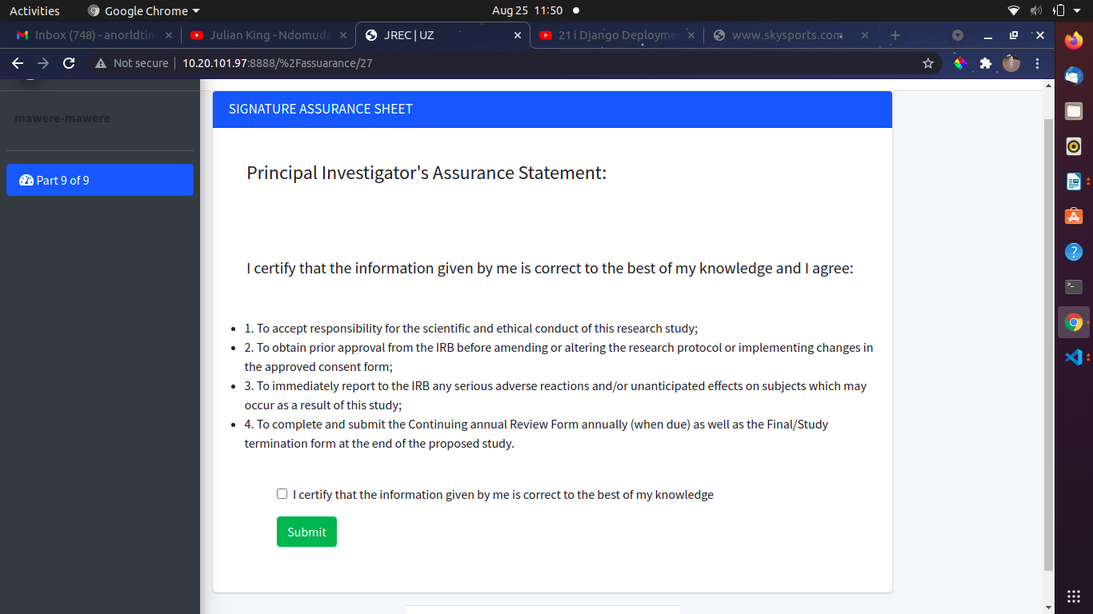

You completed your application after signing the assurance sheet, and you were notified as shown below.

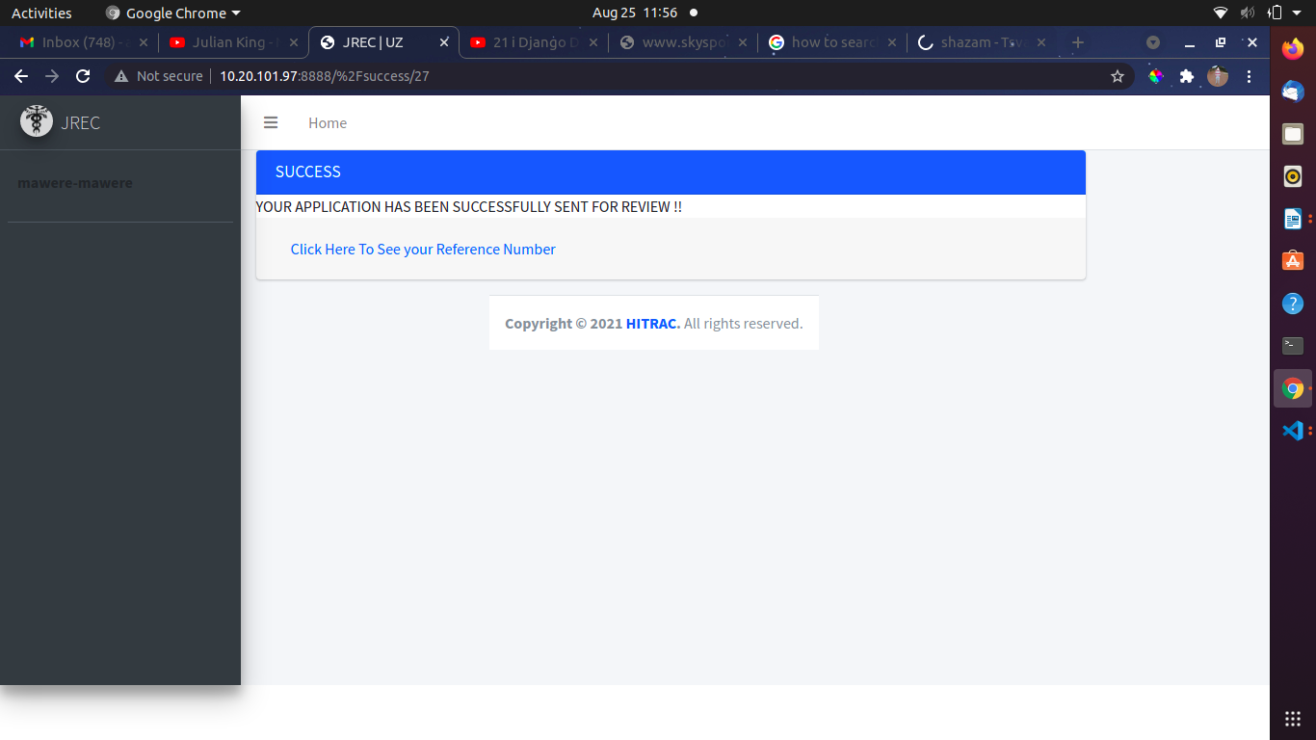

When you click to view your reference number, you will be taken to the page below.

This page displays the number of applications you have submitted, as well as the reference number and status.

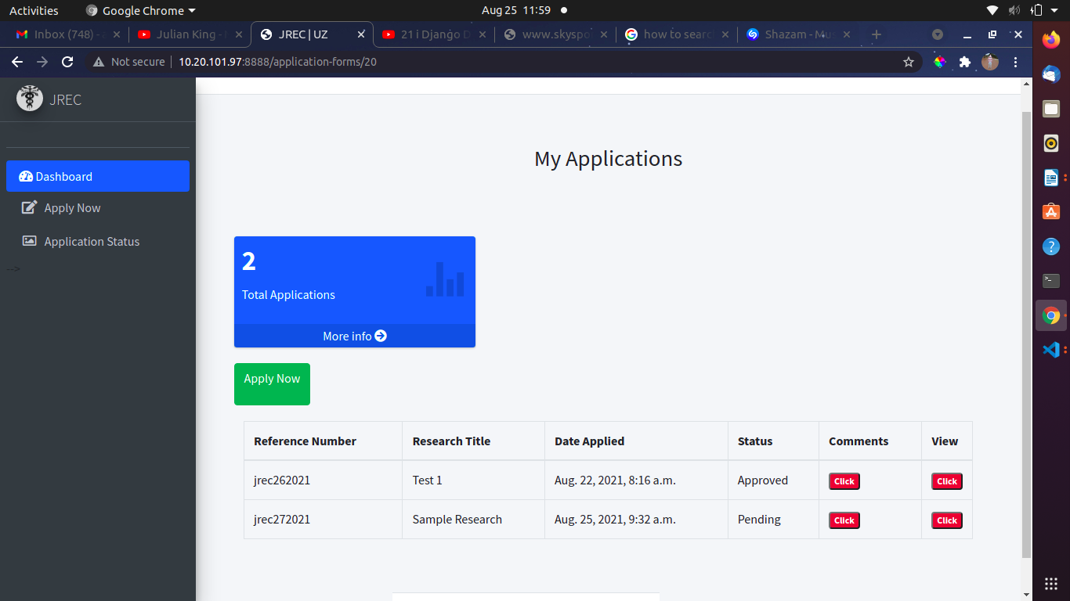

**The Admin Module**

When you login as a JREC Administrator, the admin dashboard displays all applications created and the admin can click the view button to view the full application, as shown below.

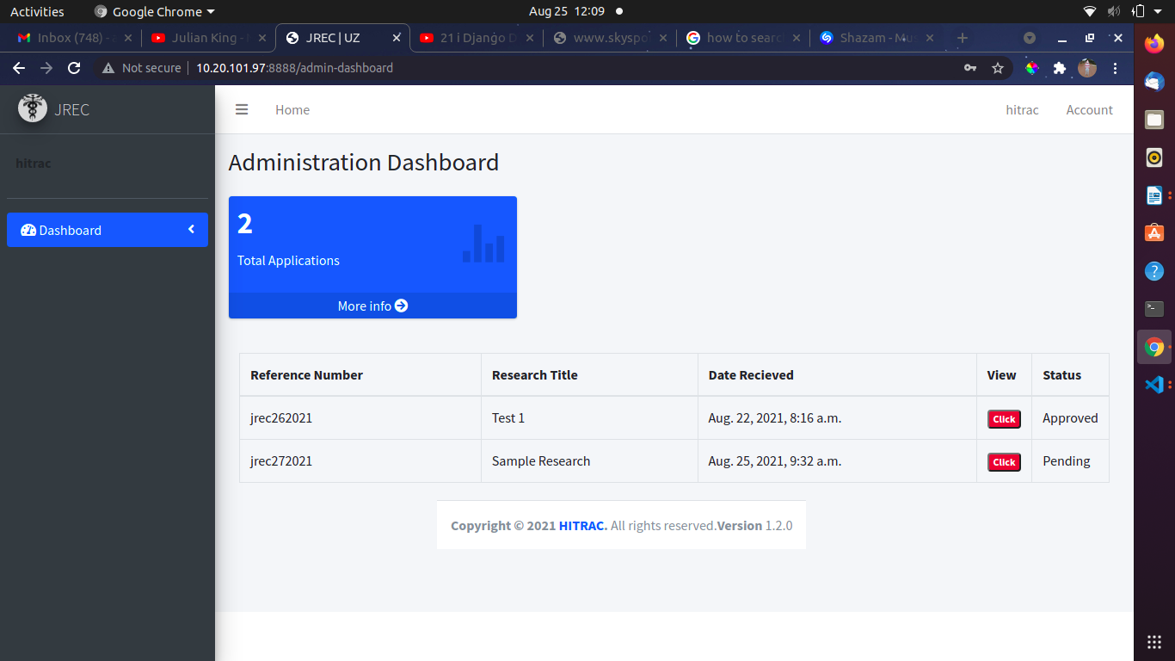

By clicking application status on the left, the admin can assign reviewers and update application status before being redirected to the next page.

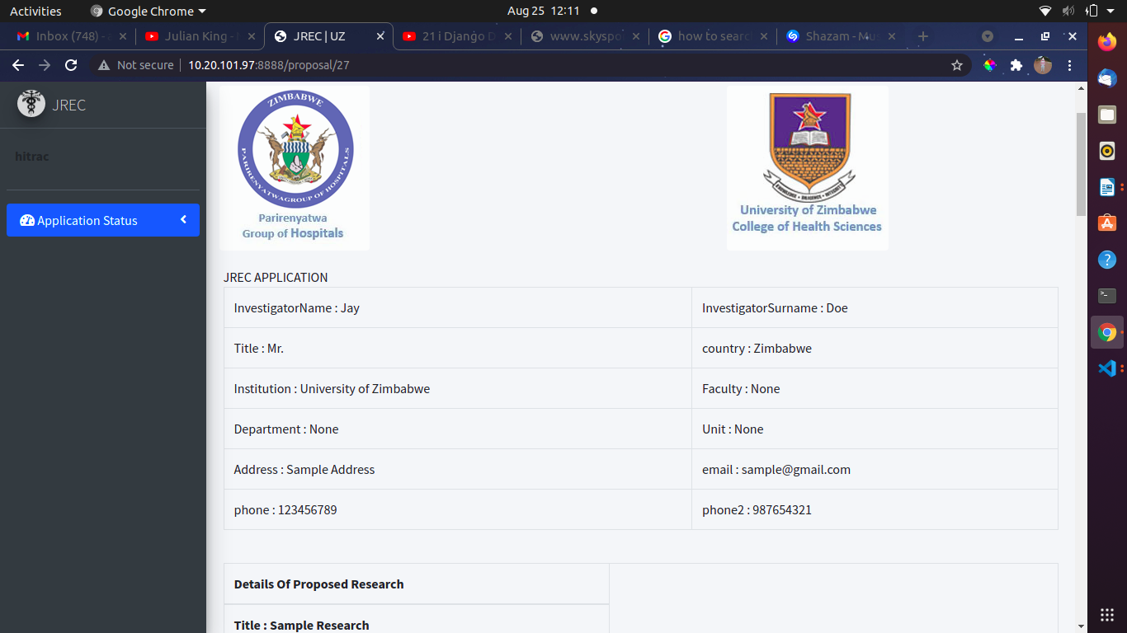

The admin can assign a reviewer, write comments for the reviewer as feedback, and view the reviewer's comments and status. Admin can also change the status so that the researcher can see it.

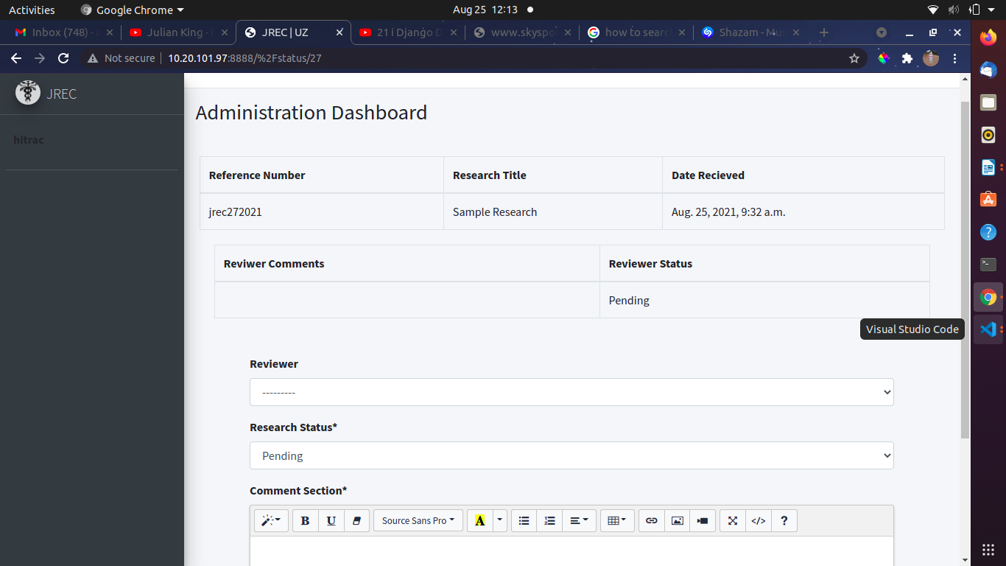

**Reviewer Module**

The reviewer dashboard displays a list of all applications created. A reviewer chooses an application that has been assigned to them by the administrator to review. For instance, suppose a reviewer has been assigned application jrec272021. They click the view button to view the entire application, which takes them to the next page.

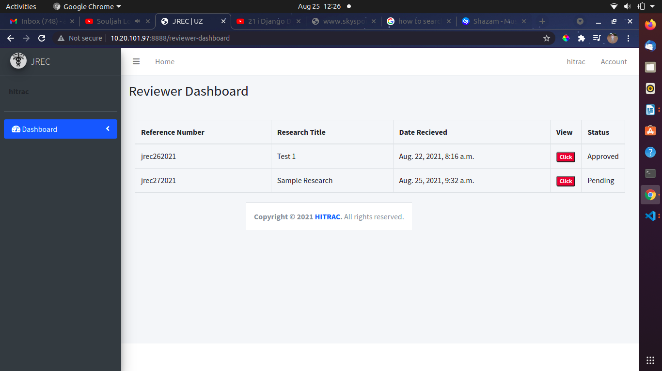

After attending to the application , reviewers give feedback through the feedback button on the left . After clicking they are then taken to the following page

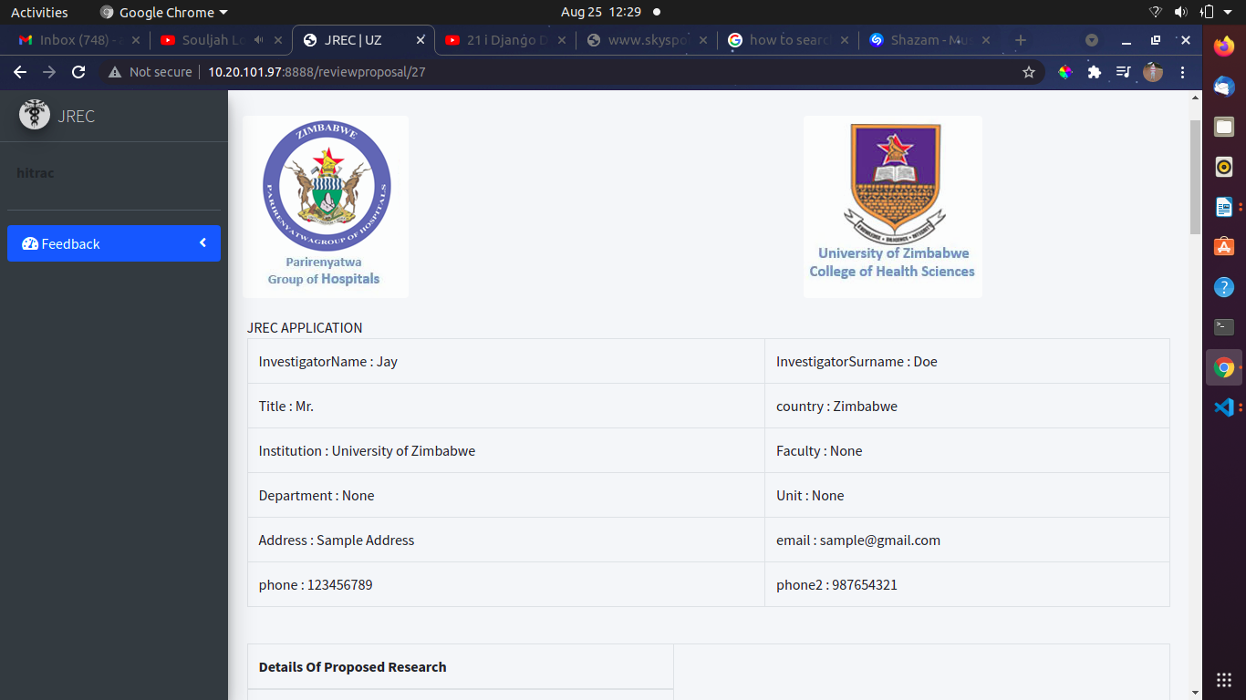

Using this page, the reviewer can update the status and leave comments. The admin will have access to the information posted here.

